**11.1. Spring MVC Behind the Scenes**

**Components of a Spring MVC Application**:

Usually Spring is used to integrate other frameworks like Struts, WebWork, Java Server Faces and Tapstry but Spring itself has built in support for MVC.

The components of Spring MVC application are

1. A set of web pages to layout UI components
2. A collection of Spring beans (controllers, services, etc.…)
3. Spring configuration (XML, Annotations or Java)

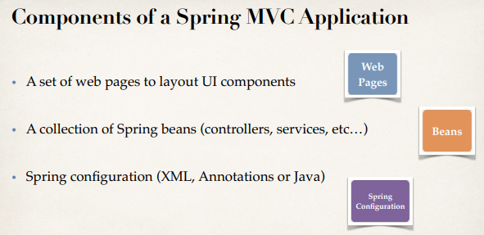

**How Spring MVC works behind the scenes**:

Everything starts off in spring with the first incoming request and it encounters something called a “FrontController”.

**Spring MVC Front Controller**:

1. 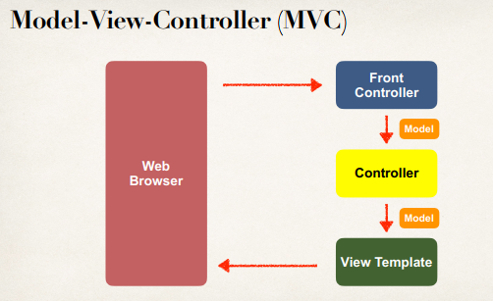Front controller known as DispatcherServlet
   1. Part of the Spring Framework
   2. Already developed by Spring Dev Team
2. You will create
   1. Model objects (orange)
   2. View templates (dark green) (JSP or view page for render data)
   3. Controller classes (yellow) (business or processor logic)

**Controller**:

1. Code created by developer
2. Contains our business logic
   1. Handle the request
   2. Store/retrieve data (db, web service…)
   3. Place data in model
3. Send to appropriate view template

**Model**:

1. Model contains our data
2. Store / retrieve data via backend system.
   1. Database, Web Service, etc.
   2. Use a spring bean if we like
   3. Place data in model
3. Place our data in the model
   1. Data can be any Java Object / Collection

**View Template**:

1. Spring MVC is flexible
   1. Supports many view templetes
2. Most common is **JSP + JSTL**
   1. Place data in model
3. Developer creates a page
   1. Display Data

**View Template (More)**:

Other view templates supported by Spring is

1. View Template
2. Velocity, Freemarker, etc…

11.1. Spring MVC Behind the Scenes